# GRAZIOSO SALVARE PROJECT 2

## About the Project/Project Title

The ability to take a large database and search through it for specific items saves so much time rather than sorting through it line by line. This program will do just that, it gives the user and option to pick an item from a drop down then update the table based on the results that it found for each specific drop-down item. In this specific project it allows Grazioso Salvare, a dog training company, to search for specific dogs in an animal shelters inventory. The company can search for different type of rescues they are looking for such as water, wilderness, or disaster. Then it allows them to reset the filter back to the full table with all the inventory it’s in. This project I uses CRUD operations from the python application to the animal shelters MongoDb database.

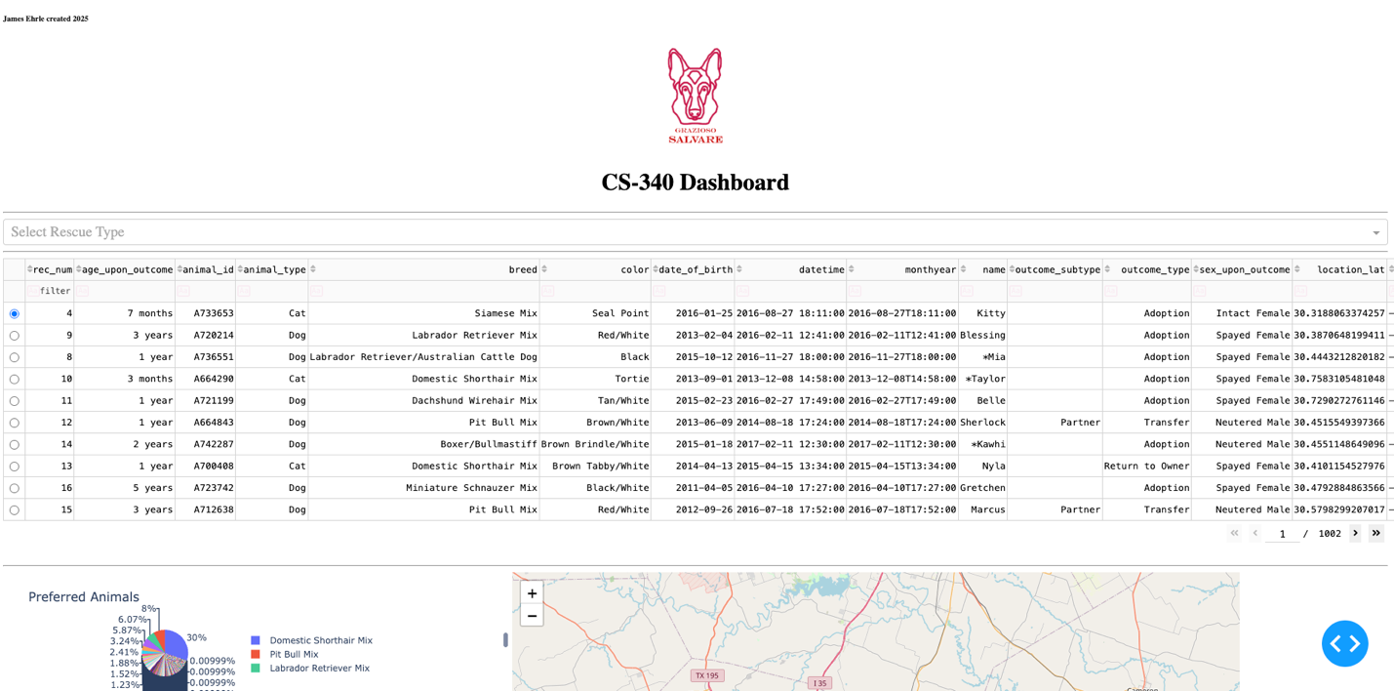

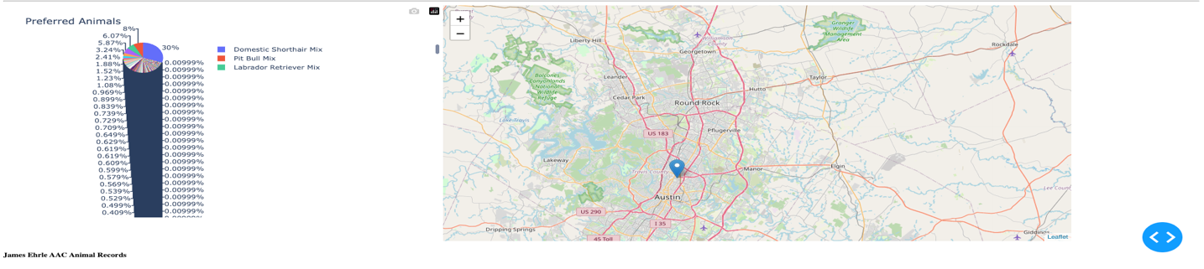

## Motivation

The motivation behind this project was the company that was looking for dogs in an animal shelter to find the specific breed that would be good for different rescue types. This was a really good project to be able to create a web application that reads the items for a MongoDb.

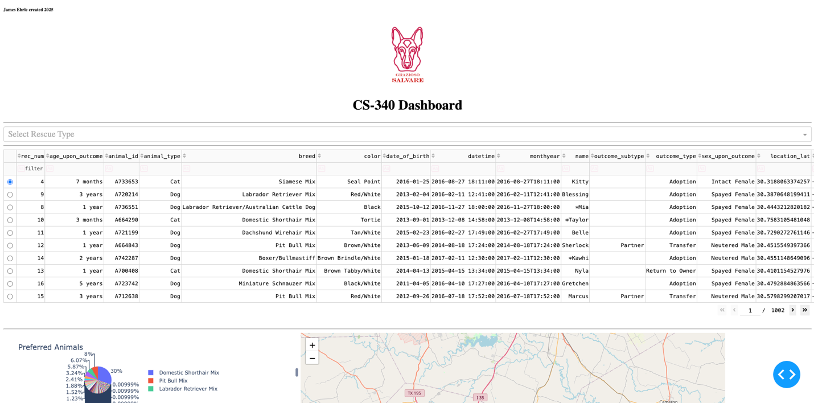

This is the landing page with everything in the database on the table and in the pie chart. When you click the logo it will take you to SNHU.edu



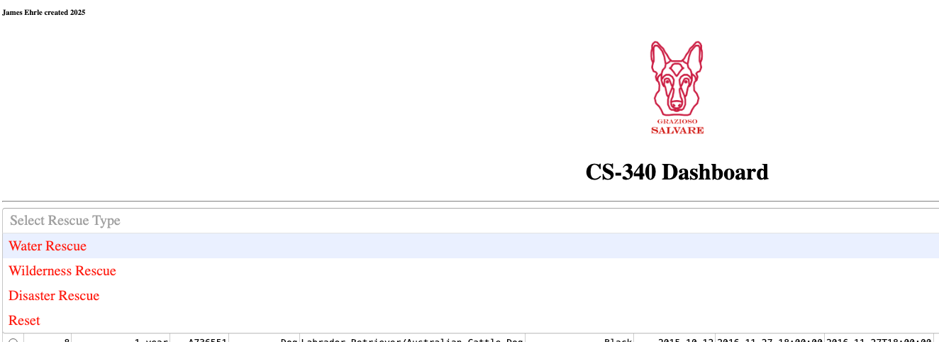

The drop down has different filter options that I made in red to help link the color from the logo to more on the page.

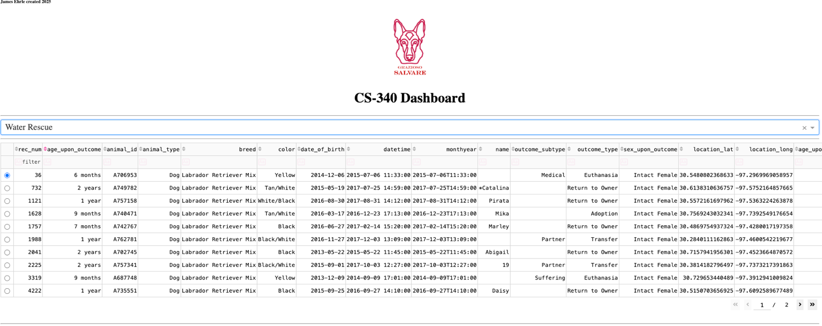

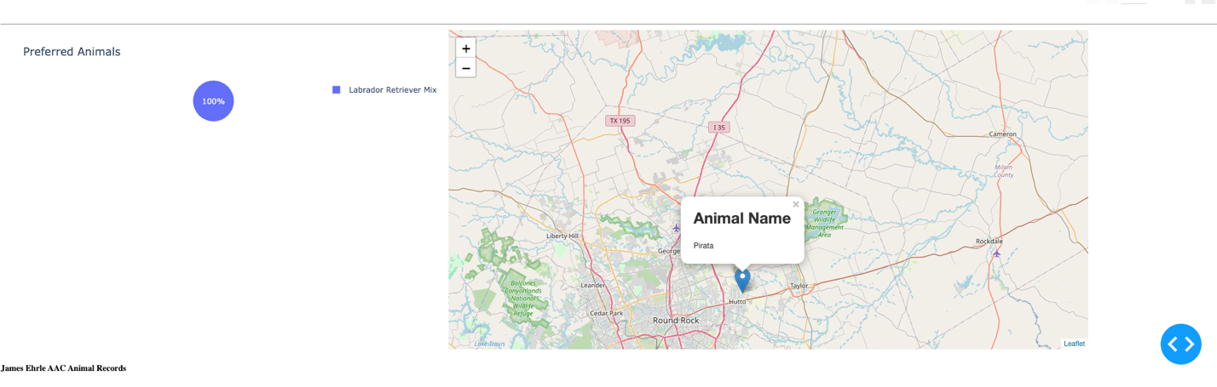

This is the example of when water rescue it selected.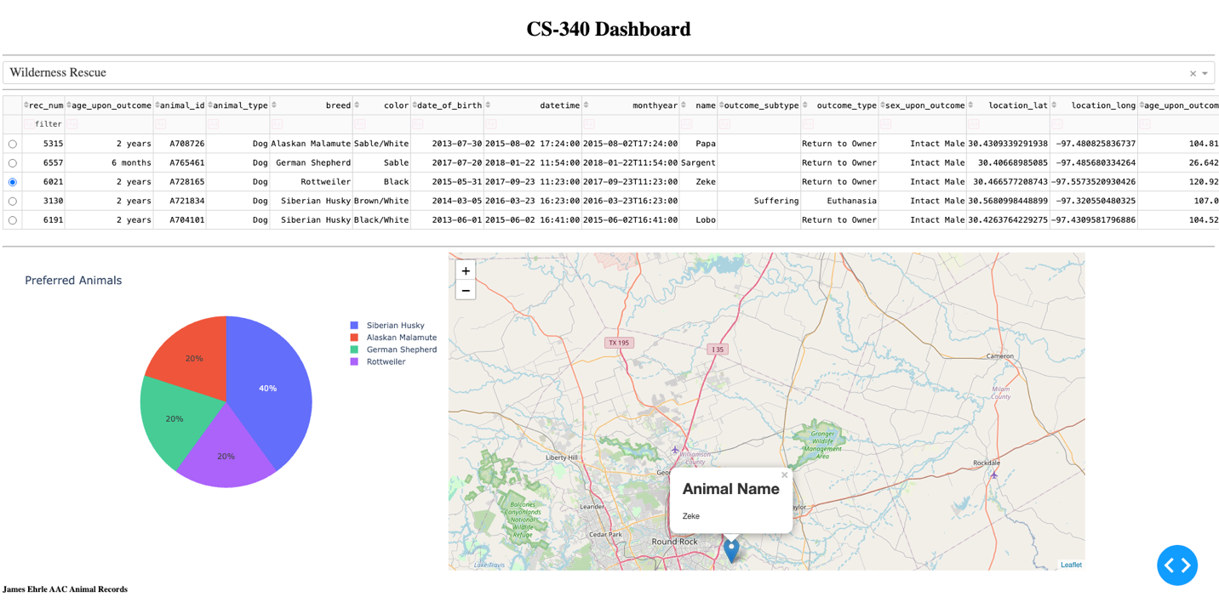

This is an example of when the wilderness rescue is selected.

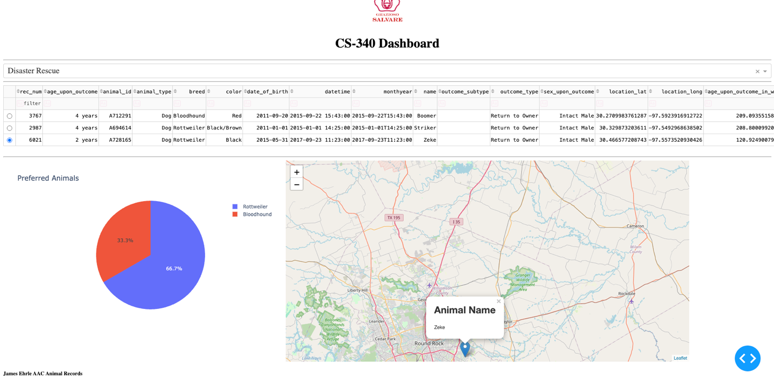

This is an example of when disaster rescue is selected.

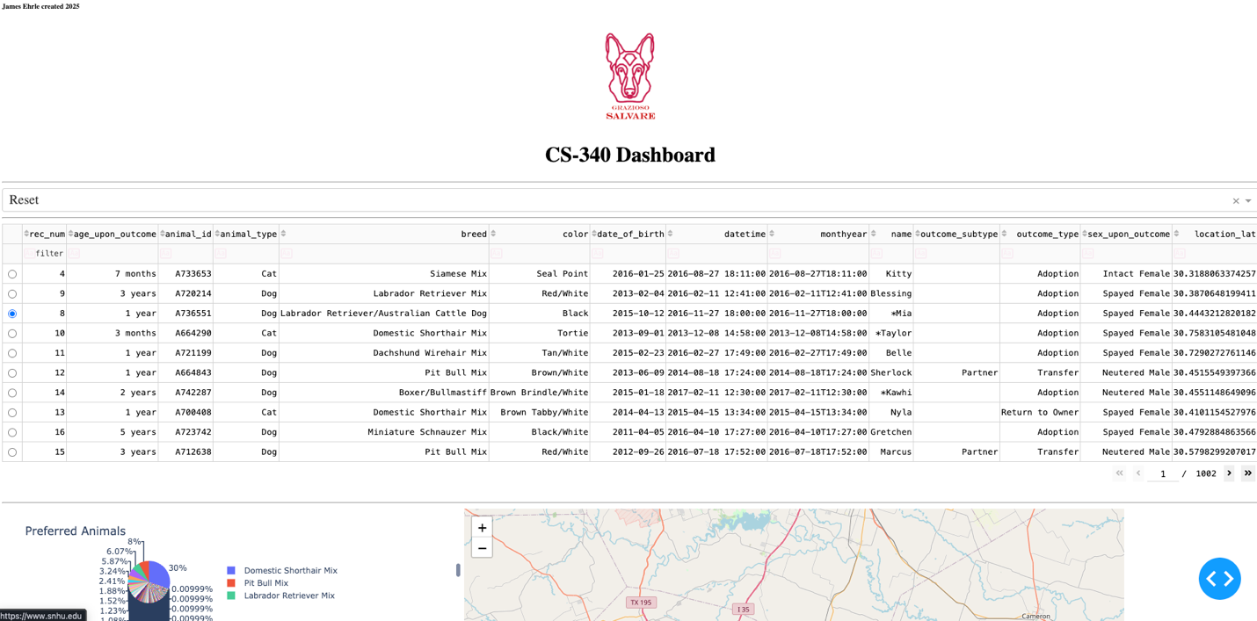

This is an example of when the reset is selected.

## Getting Started

To get started you will need to have access to Jupyter Labs this will be the python code and an active Mongo DB database and import the database using the command “mongoimport --db aac --collection animals --type csv --file ./aac_shelter_outcomes.csv –-headerline”

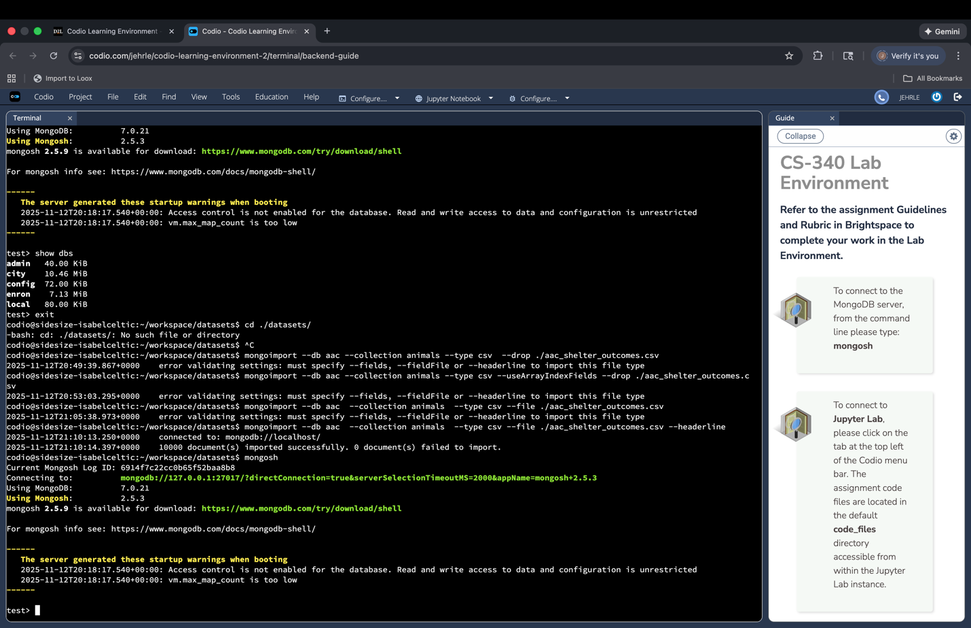

Then you will need to access the admin database to create a user that can read and update the database. This is done by using the command “db.createUser({user: "aacuser", pwd: "SNHU1234", roles: [ {role: "readWrite", db: "aac"} ]})”.

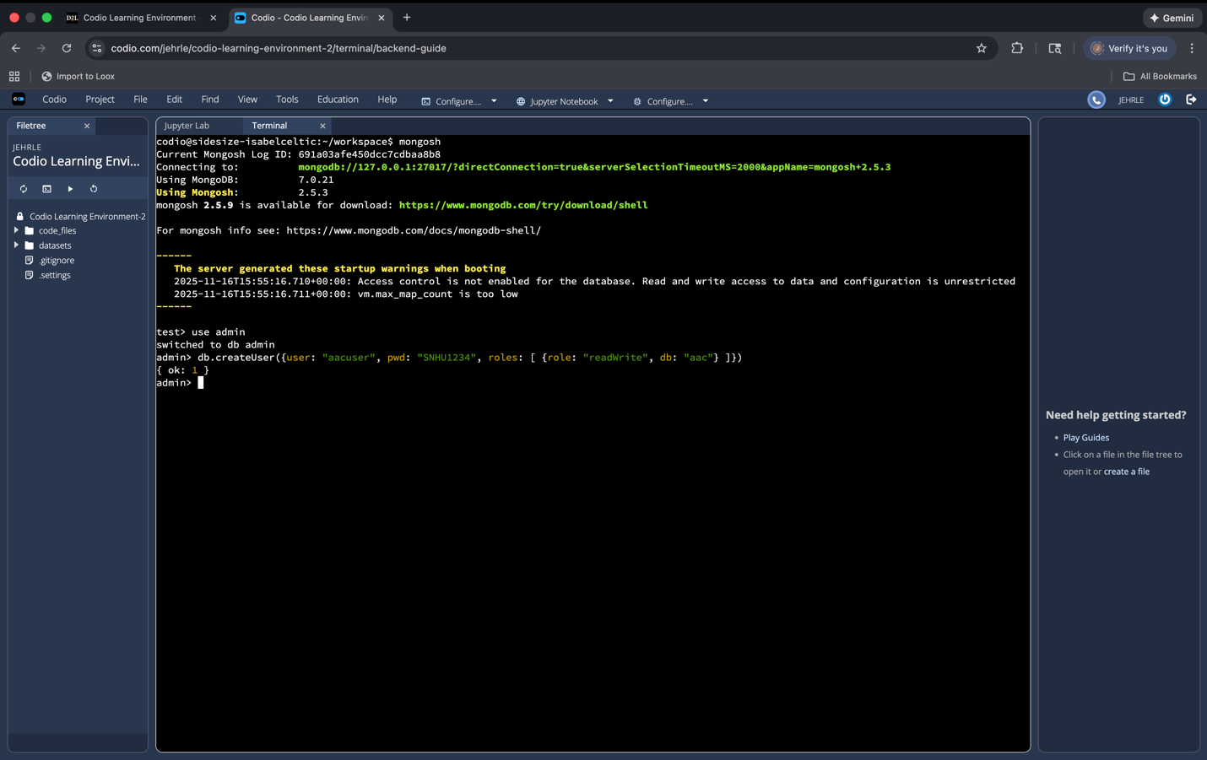

Then you will need to make sure that you log in using that user.

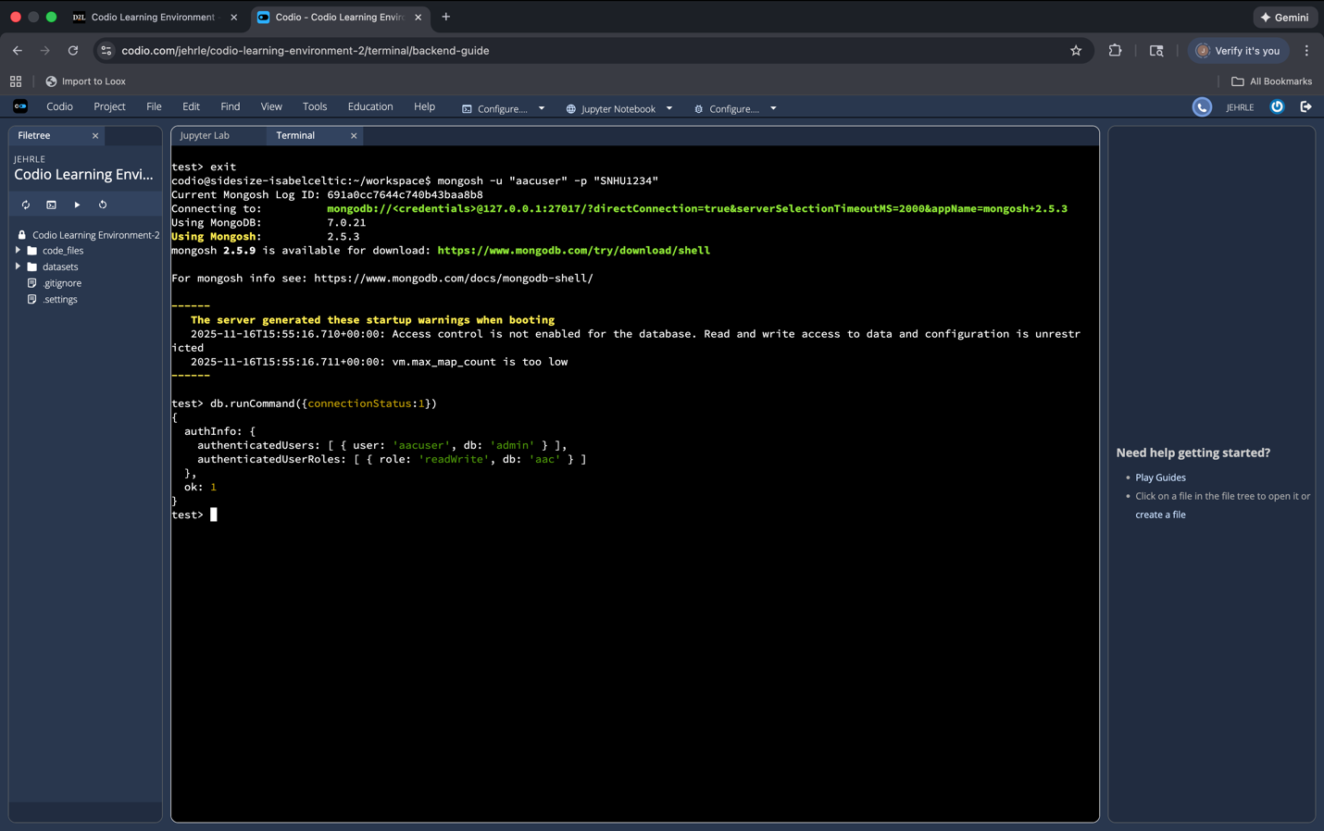

You will need to use the mongosh shell using the “mongosh -u "aacuser" -p "SNHU1234"” command then verify the connection status using the db.runCommand({connectionStatus:1}) command and it verified that I was in the correct log in information. This will start the process of gaining access to the aac database then being able to use the python code to use the CRUD operations. Some challenges that I had was creating the user for the database because you will need the admin and sign in with the correct username and password that was created for the user. To set up the python code you will need to create a function of Animal shelter then use the connection variables to connect to the aac database (these will be the username and password that you created):

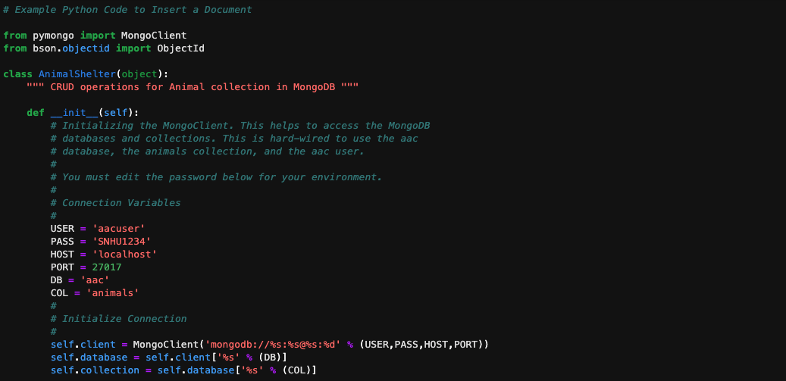

After that you will need to create each letter function of CRUD. Create, read, update and delete:\

CREATE:

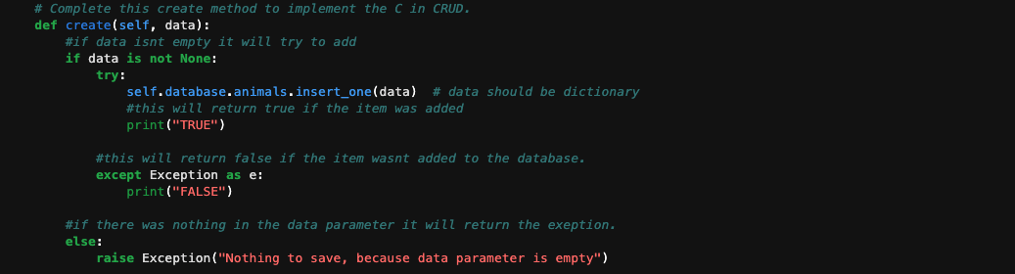

READ:

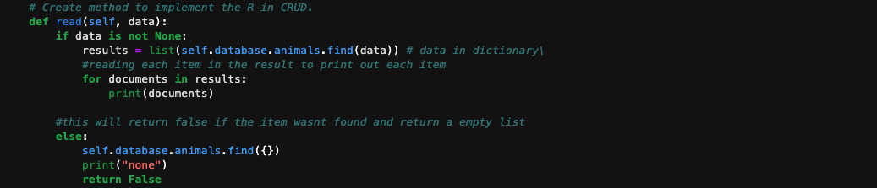

UPDATE:

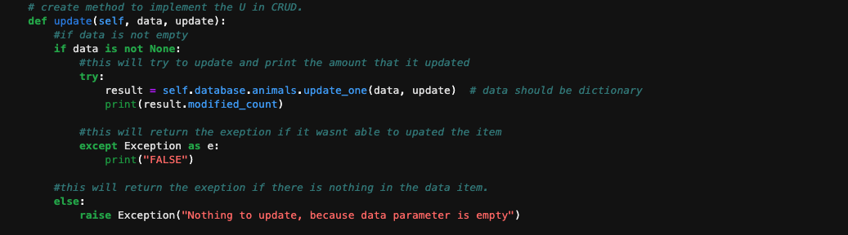

DELETE:

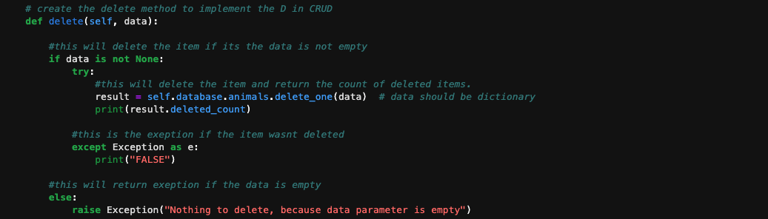

Then when you have your database access and CRUD functions all set up.

You will need to set up the dashboard.ipynl this is where you will create the dashboard for the web application. You will need to import these different libraries and connect to the CRUD python module and class name.

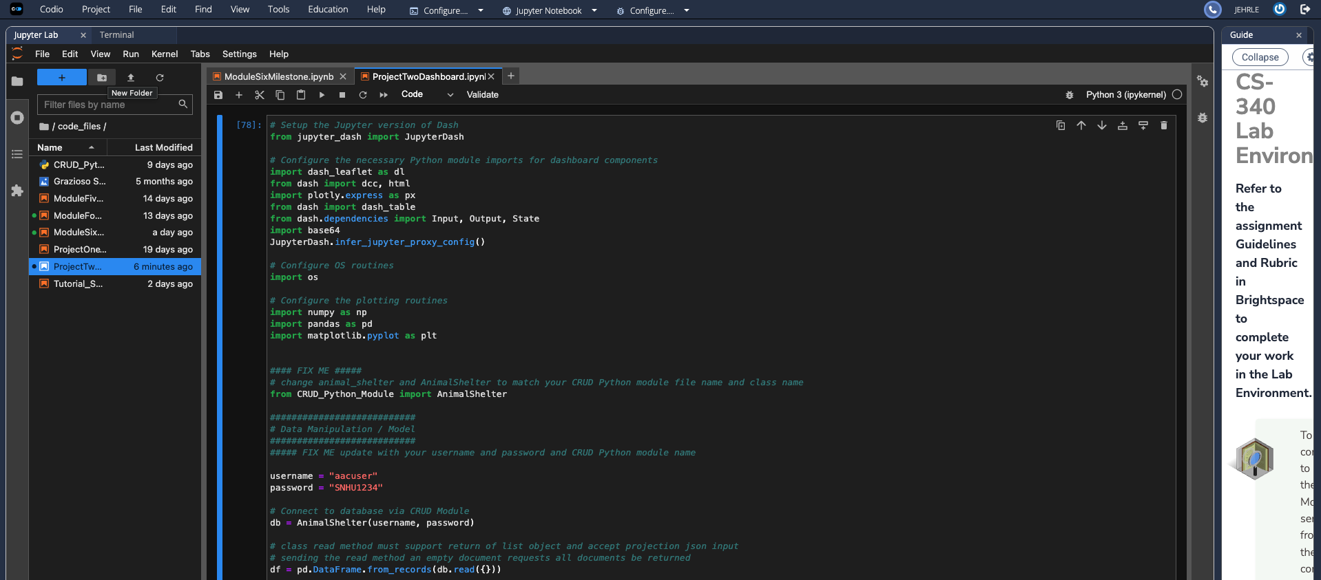

Once you have imported that you will need to use the username and password you set up to connect to the DB then create an instance of it as db. The read function will be the main function you use from your CRUD module, but it will still be useful in the future to have the rest of the items set up.

Then you will need to use the df.drop(columns=['_id'],inplace=True) to clean up and allow it to drop the columns if it doesn’t have what id.

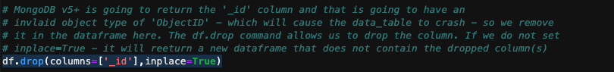

Next you will need to add the image_filename and the .read to open it.

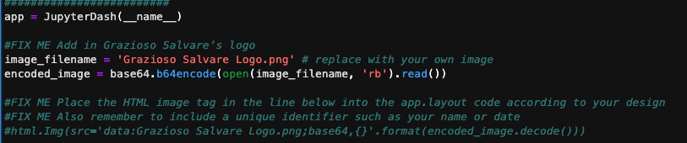

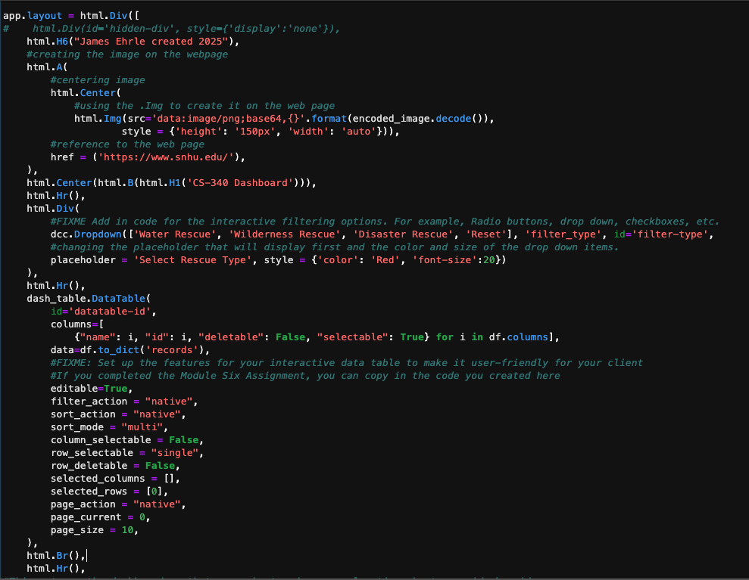

This is the code that you will need to use to set up the app lay out, it starts with the header on the left hand side which it the unque identifier, then it goes in to the image that is the html.A then centering it then using the html.Img to add the image. Then using the href to reference the home page ( this will allow the user to click it and go back to the home page). To set up the drop down you will need to use the html.Div() then add the dcc.Dropdown() and add the different items that you are wanting in the drop down. The rest of the code in the screen shot is setting up the table based on your specific requirments.

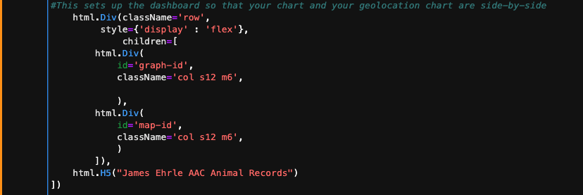

This is setting up the graph and the maps to where they will be beside each other once they have the code that is needed.

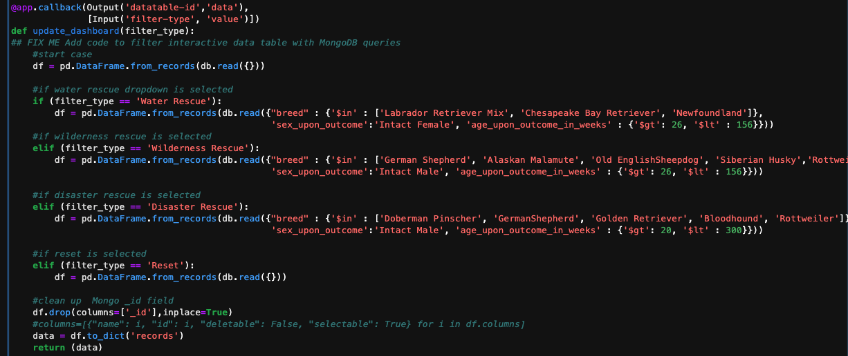

To have the dropdowns work correctly you will need to read in the filter type then create your if and elif statements for each of your different items then use the df = pd.DataFrame.from_record(db.read({}) to read what you are needing from each different drop down then when you return the data it will update the table. Then when setting up the graph you will need to update that as well so you will use dff = pd.DataFrame.from_dict(viewData) to update the graph then

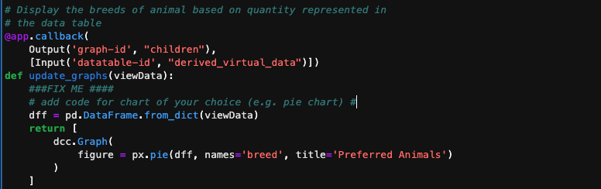

The graph figure will use the dff and the items that you would like such as breed and preferred animals.

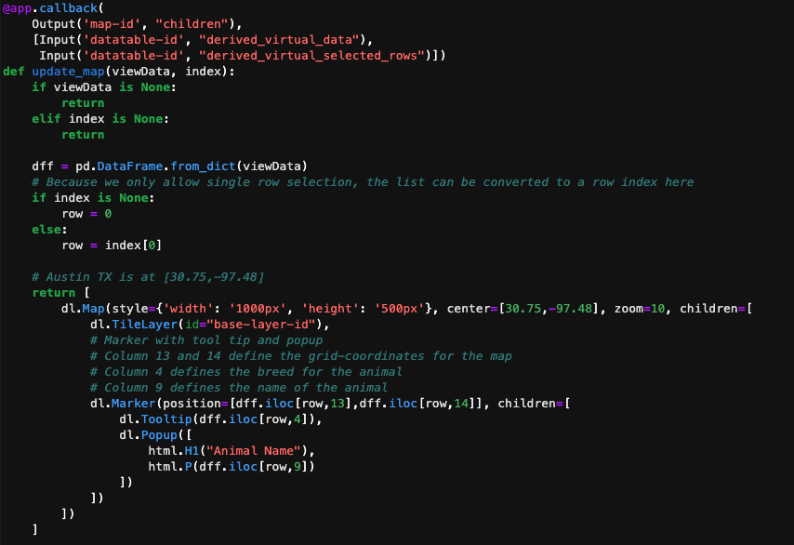

Lastly you will need to be able to add the map function which is the update_map function.

## Installation

The tool that will be need:

* Jupyter Lab
  + Jupyter lab is the IDE that was used for this project for the python code to execute but you could use other IDE such as PyCharm. This will be needed to create, modify, test, and run the python code.
* Mongo DB or Mongosh in the terminal
  + MongoDB is the database that we will be using in this project, this is a NO SQL database. This is where the items will be saved and able to be modified.
* MongoClient from pymongo
  + This is a library that you will need to call so you can connect the Python code to the mongo database.
* Bson.objectid from ObjectId
  + Calling allows you to call the _id field and allows you to look up the items in the database.
* import dash_leaflet as dl
  + this will be to import the interactive map
* from dash import dcc, html
  + this library will include the different interactive filtering options such as radio buttons, drop downs, checkboxes, etc.
* from dash import dash_table
  + this library will include the table.
* import plotly.express as px
  + this library will include the graphs like the pie chart.

## Usage

### Code Example

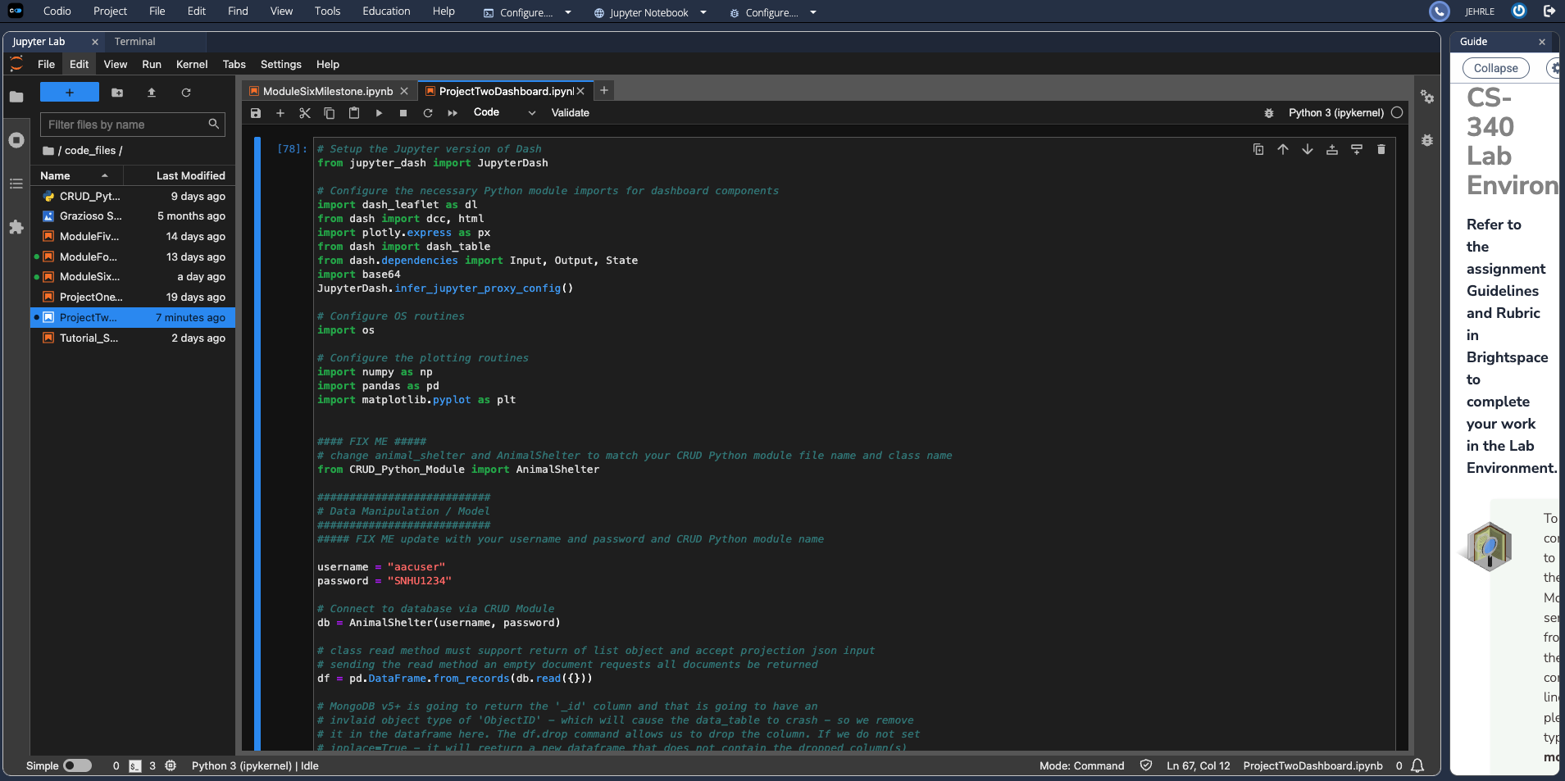

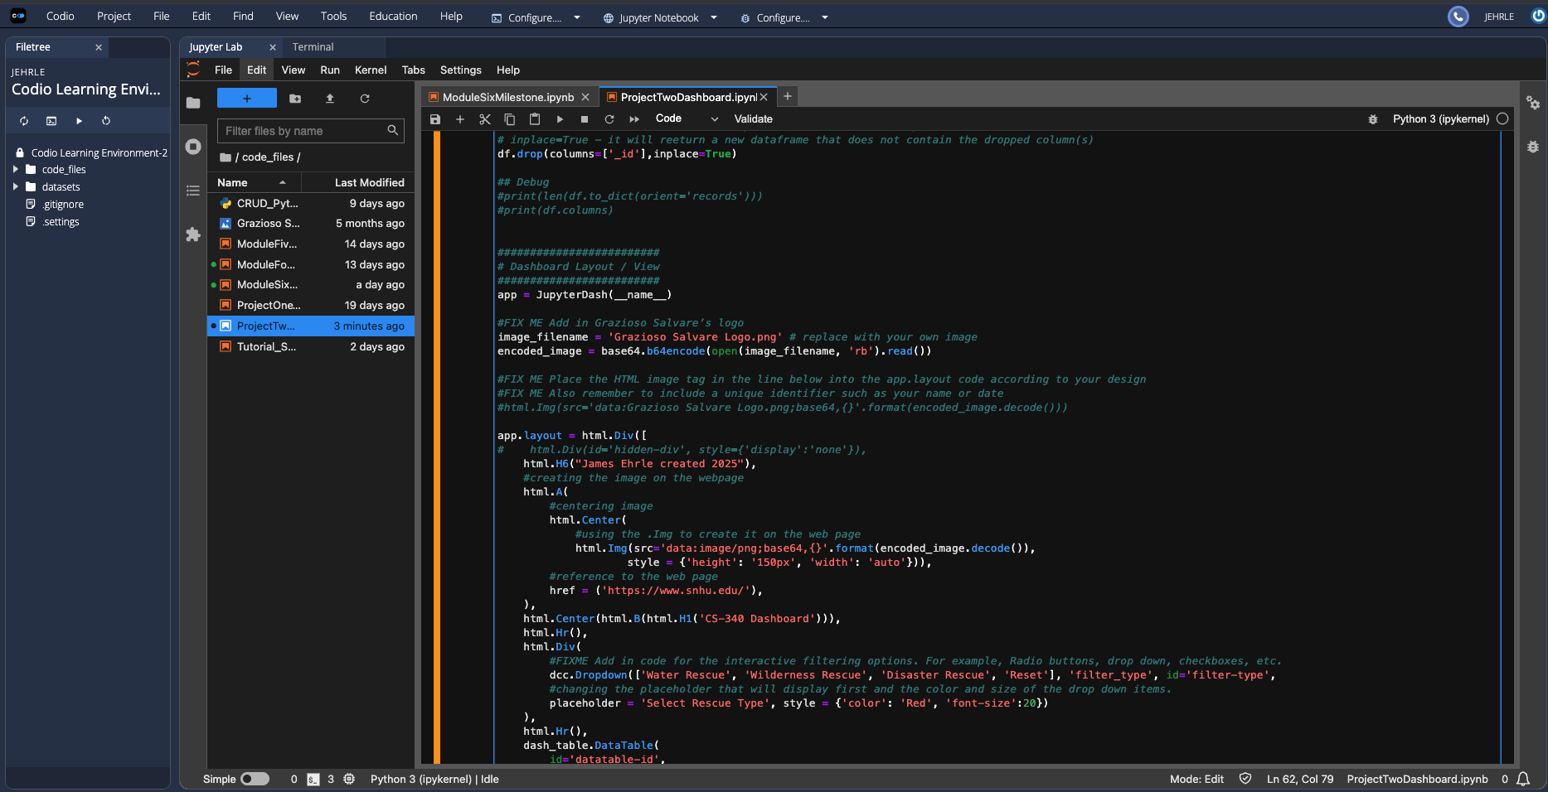

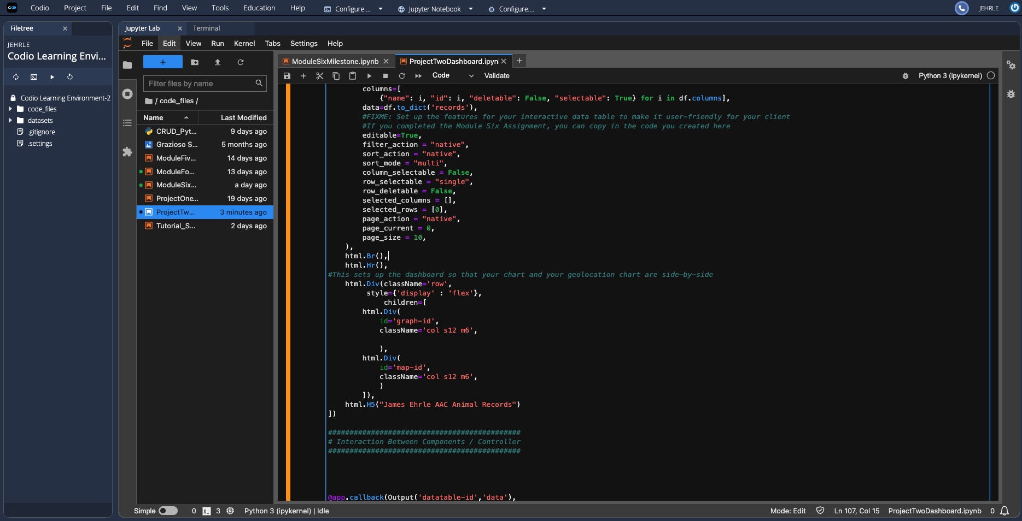

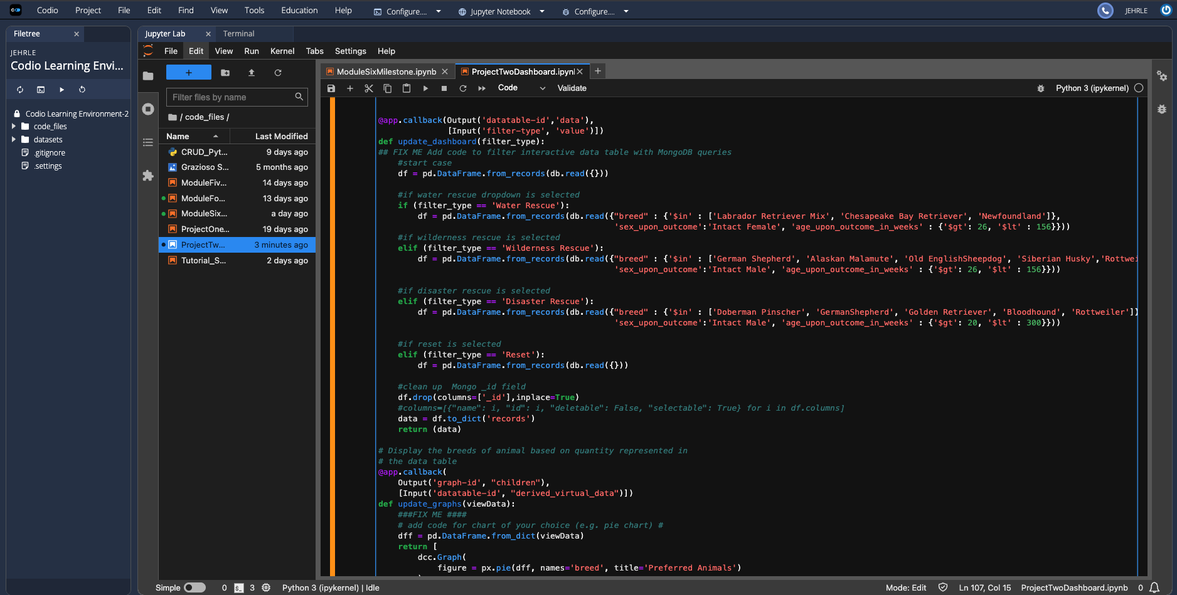

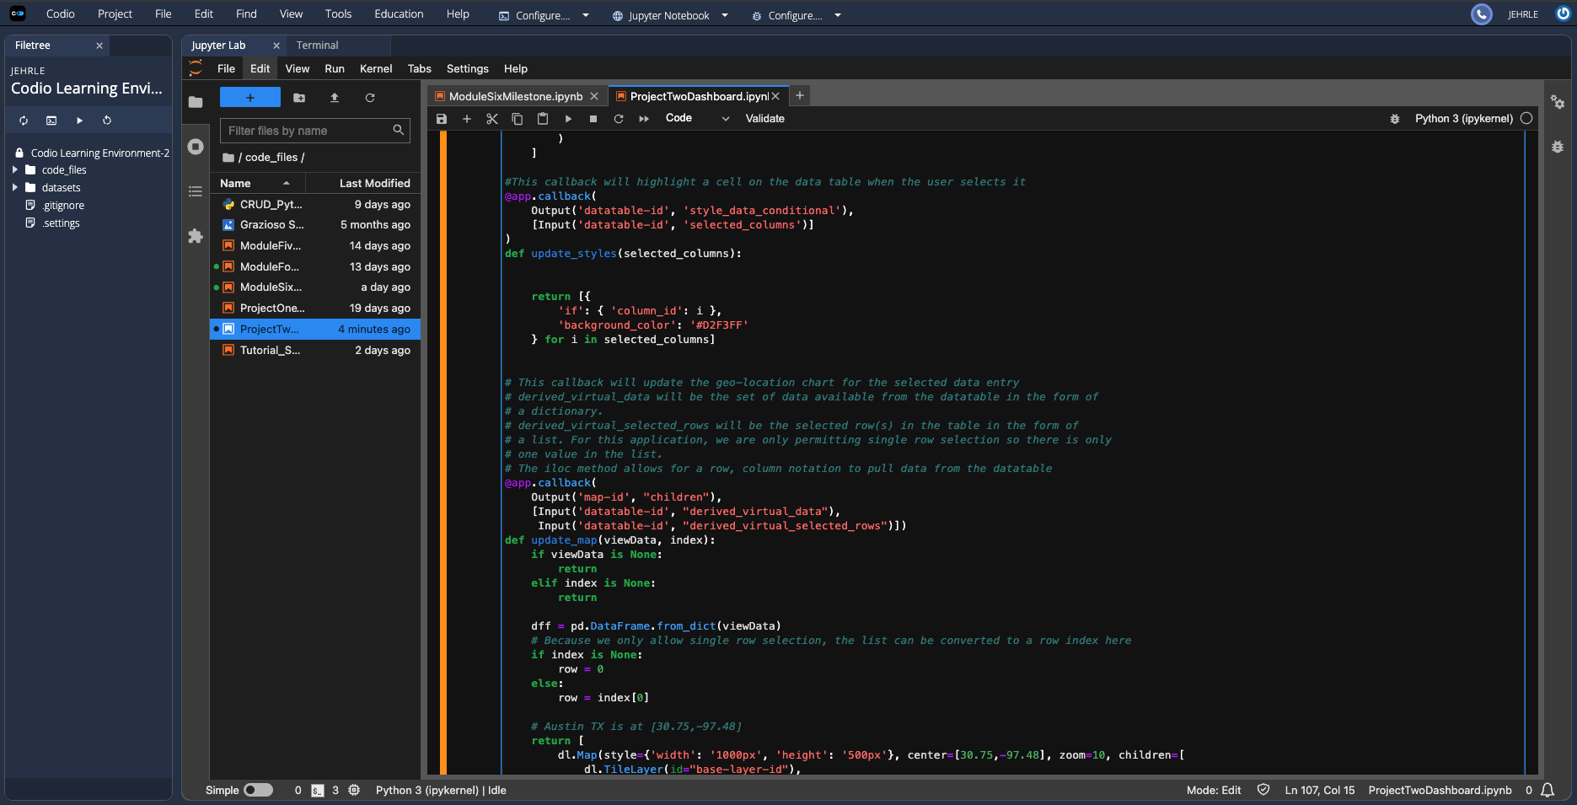

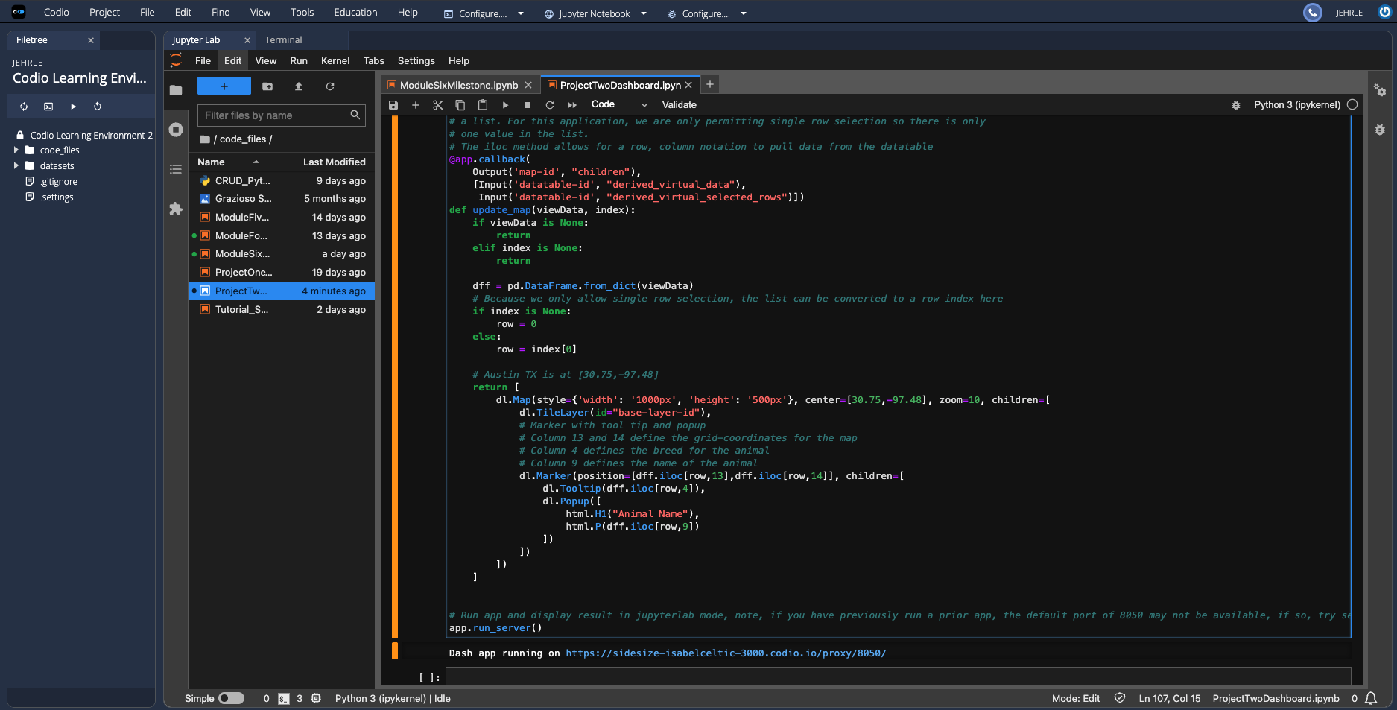

### Tests

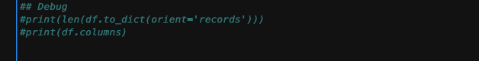

This is one of the tests that I was able to run through the process to check to make sure the records were importing correctly. Other test that I did was as I developed each thing, I would run it on a basic command. When I was developing the pie chart, I would change an item then run it. when I was developing the drop down, I started with basic drop downs then ran it and once I had it exact, I used the correct dropdowns. When figuring out how to make the filters work I had it filter basic items like animal_type so it wasn’t so much to redo if it was wrong.

A challenge that I ran into was getting the drop down to filter the table and the item that I was missing was the filter_type instead of the filter-type for the value of what each item was equal to.

## Contact

Your name: James Ehrle